Sometimes the browser tools will give some debugging help as I have mentioned. Here is an example.
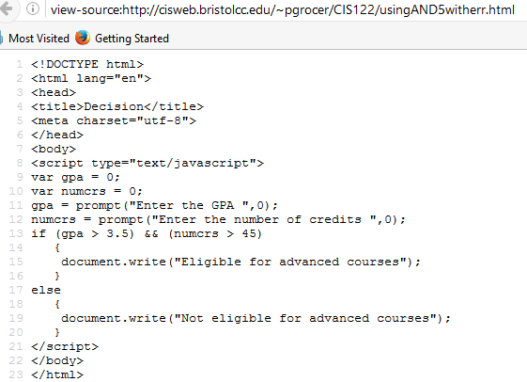

In Firefox for example, the Tools, Web Developer, Web Console has come up with the fact that the && is a problem on the if statement line. The condition about gpa is in parenthesis and so it sees that as the condition and wonders what the && is.

